1. **ReactJs HOL Solutions**

**App.js**

import React from 'react';

import './App.css';

import OfficeItem from './OfficeItem'; // Importing the component

function App() {

const officeList = [

{ Name: "DBS", Rent: 50000, Address: "Chennai", Img: "https://example.com/dbs.jpg" },

{ Name: "WeWork", Rent: 75000, Address: "Bangalore", Img: "https://example.com/wework.jpg" },

{ Name: "SmartWorks", Rent: 45000, Address: "Hyderabad", Img: "https://example.com/smartworks.jpg" }

];

return (

<div className="App">

<h1>Office Space, at Affordable Range</h1>

{officeList.map((item, index) => (

<OfficeItem key={index} office={item} />

))}

</div>

);

}

export default App;

**OfficeItem.js**

import React from 'react';

import './App.css';

import officeImage from './Picture1.png';

function OfficeItem({ office }) {

const rentColor = office.Rent <= 60000 ? 'textRed' : 'textGreen';

return (

<div className="office-card">

<img src={officeImage} alt="Office Space" width="25%" height="25%" />

<h2>Name: {office.Name}</h2>

<h3 className={rentColor}>Rent: Rs. {office.Rent}</h3>

<h3>Address: {office.Address}</h3>

</div>

);

}

export default OfficeItem;

**App.css**

.textRed {

color: red;

}

.textGreen {

color: green;

}

.office-card {

margin: 20px;

padding: 10px;

border: 1px solid gray;

border-radius: 8px;

width: 300px;

}

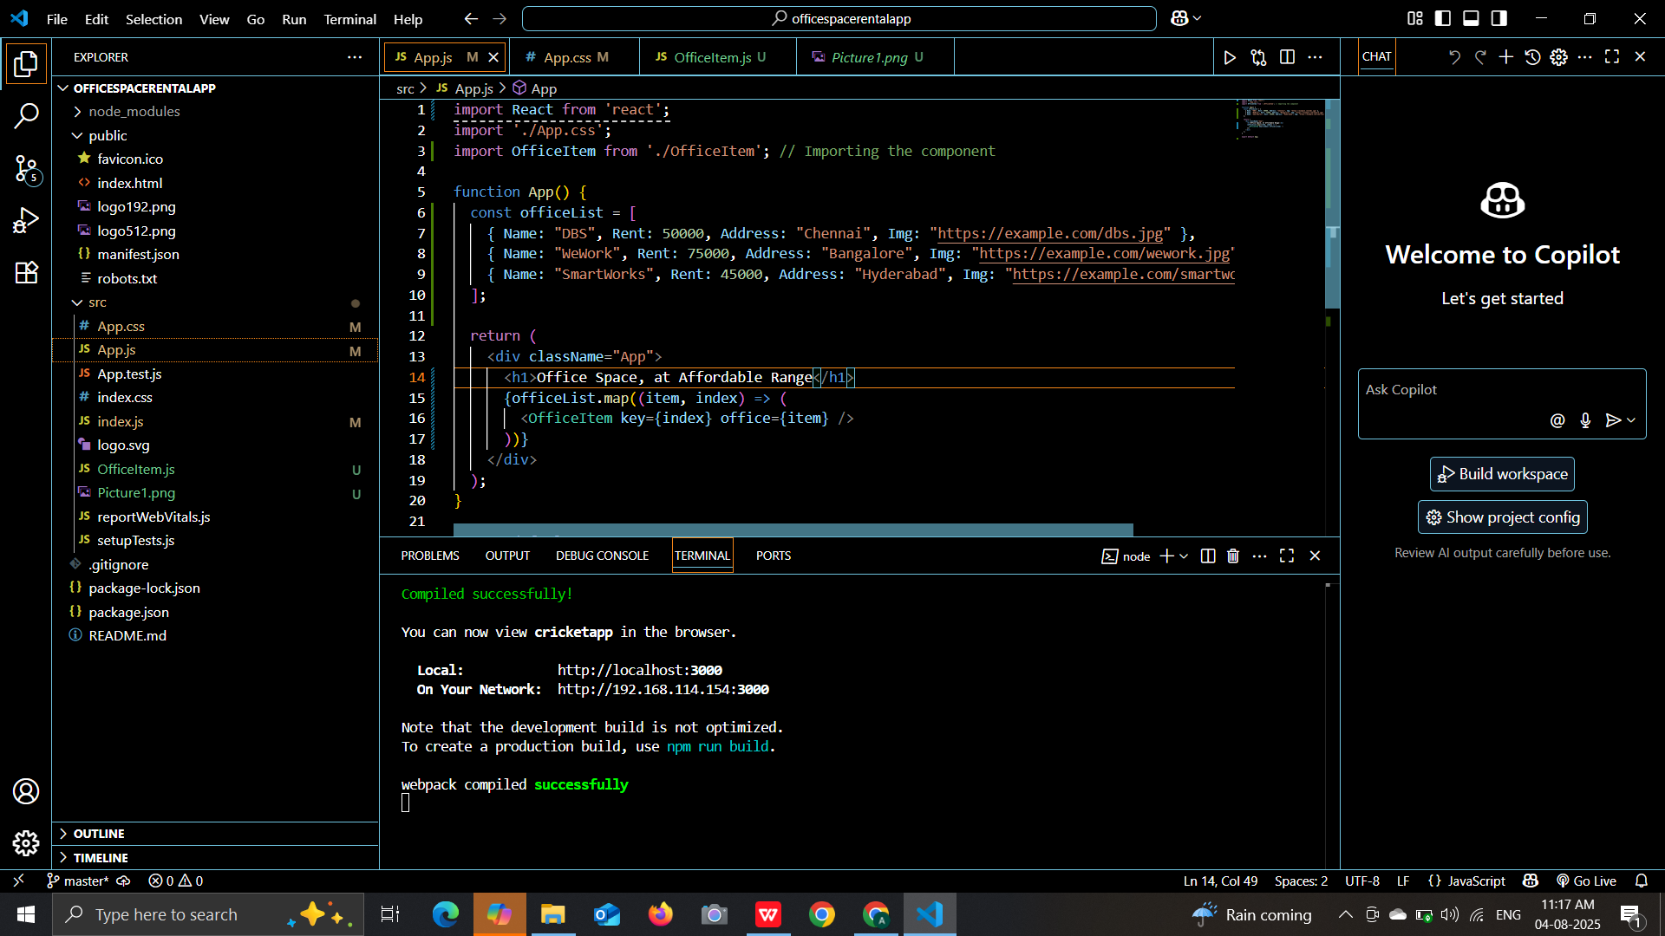

**OUTPUT:**

